Jackson Warren

Jeremy Bergen

CSCI 370

11/22/21

Week 12: Lab 11

Part 1:

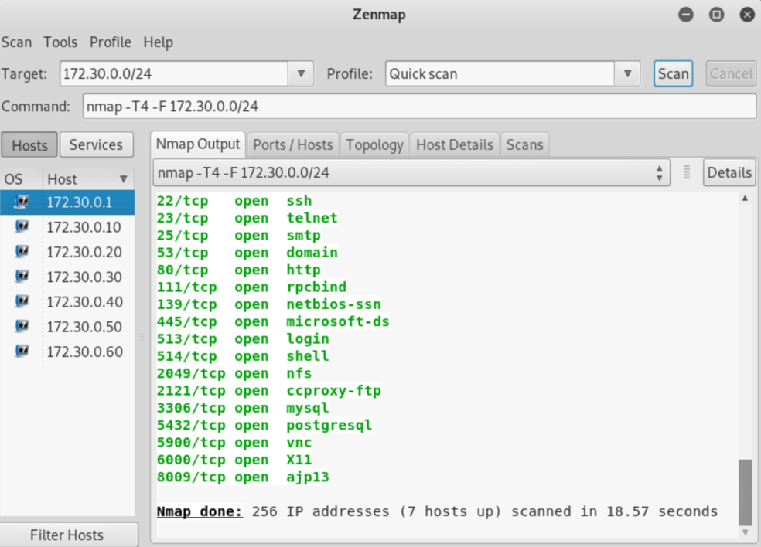

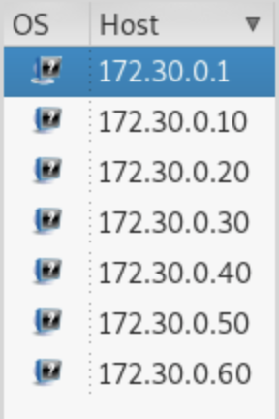

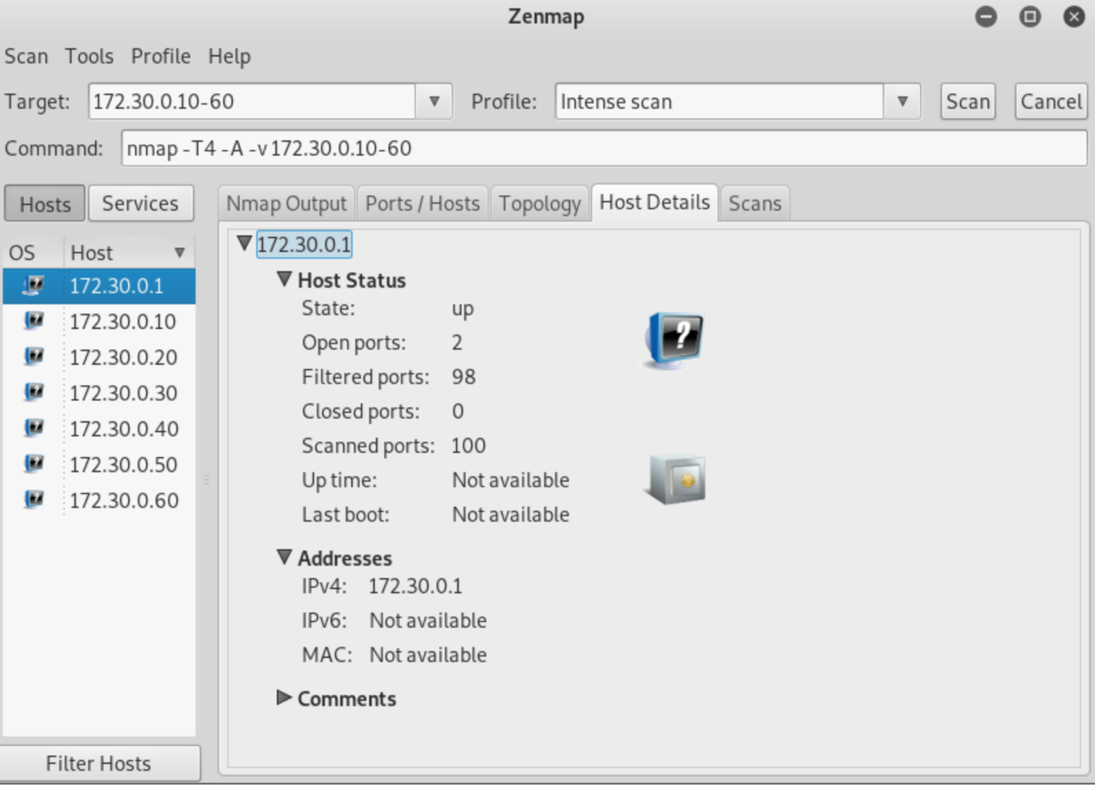

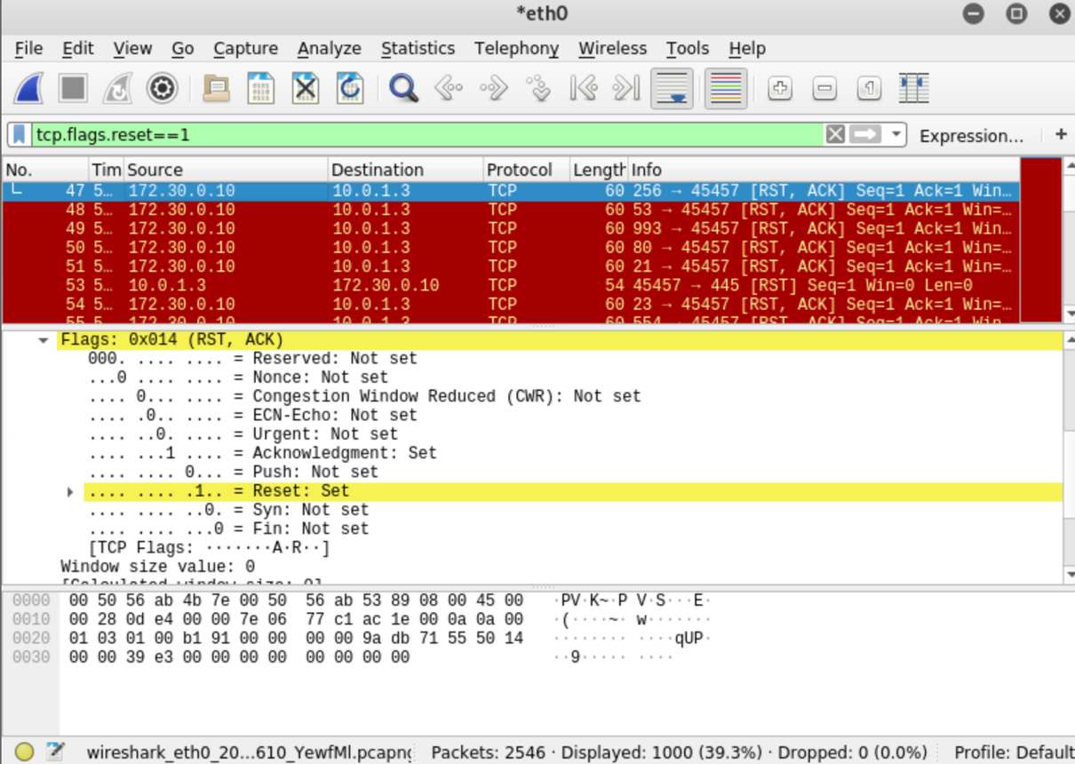

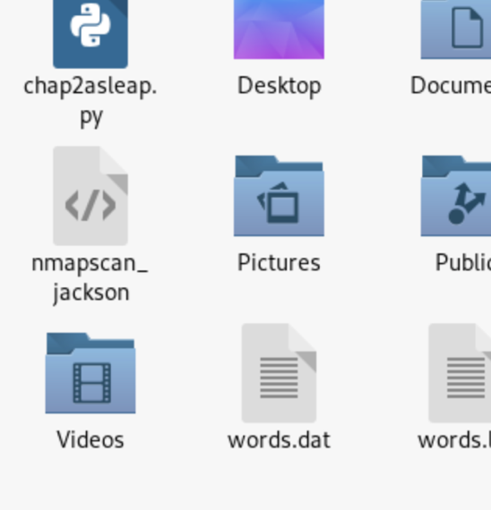

Part 2:

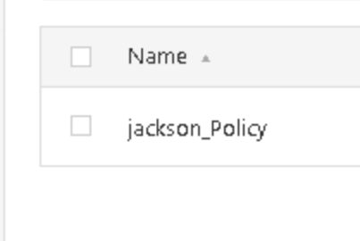

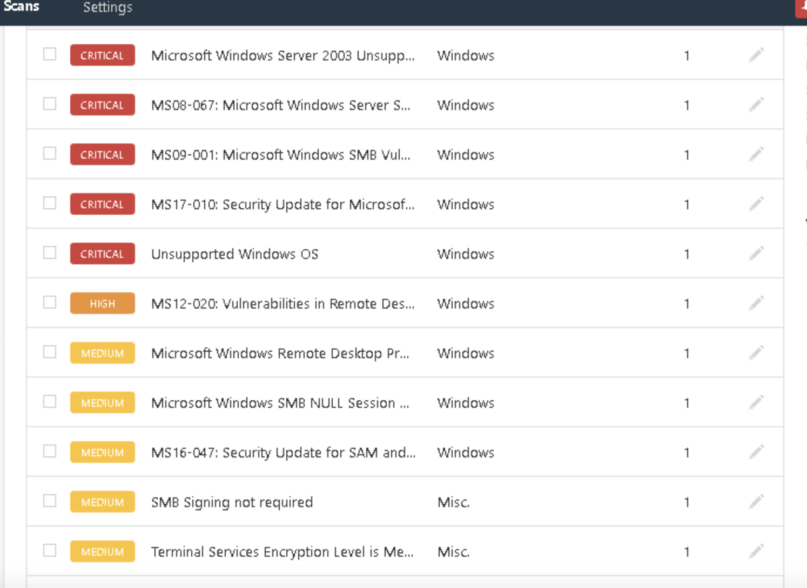

I think all of these findings tell us that our system is not very secure at all. We have an unsupported OS, out of date security, servers down or unsupported or unsecure, weaknesses with the remote desktop, etc. Really, just a bad system with a lot lacking in security.

Part 3:

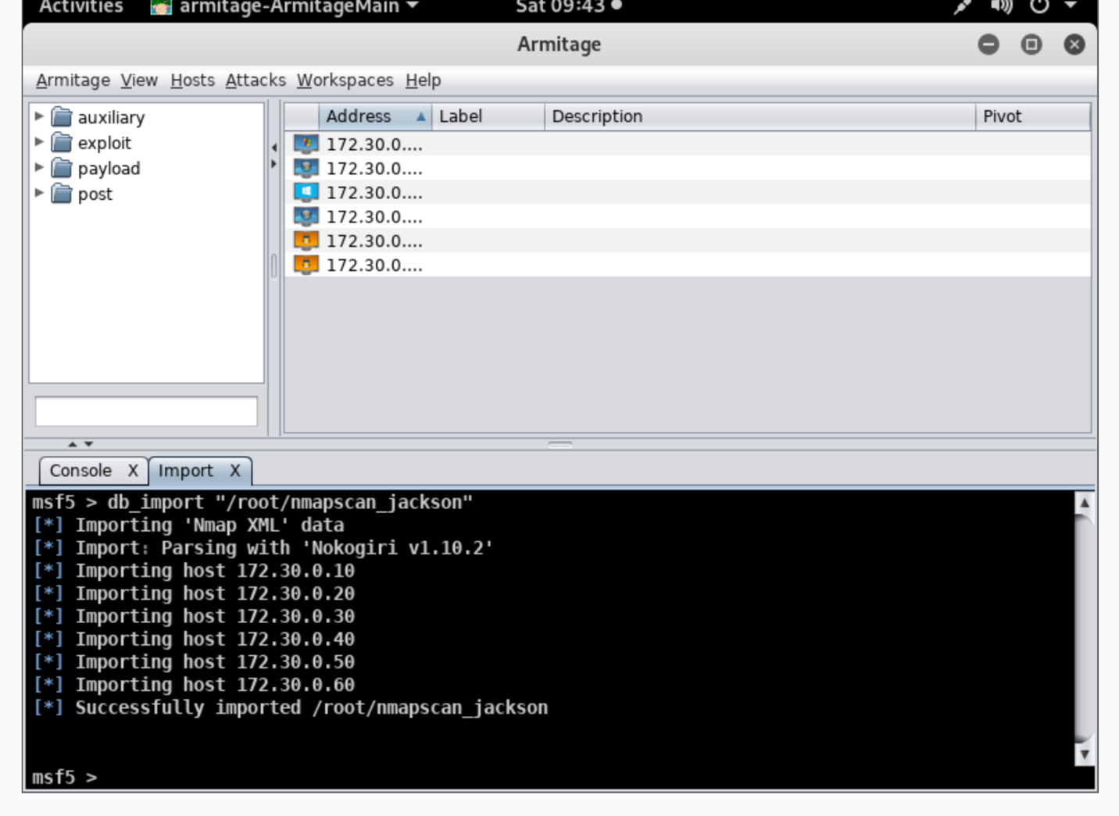

Challenge Exercises:

Part 1: This intense scan with UDP takes so long majorly because of the UDP packets. When running, the lack of response from these UDP packets may cause this increase in time. It is also scanning more ports, many of which are not the common TCP ports that are scanned with the quicker scans.

Part 2:

NULL: Nmap –sN -T4 -O -F –version-light -oX /root/storage1 172.30.0.10-60

ACK: Nmap –sA -T4 -O -F –version-light -oX /root/storage2 172.30.0.10-60

Xmas: Nmap –sX -T4 -O -F –version-light -oX /root/storage3 172.30.0.10-60

Non-TCP: Nmap –sU -T4 -O -F –version-light -oX /root/storage4 172.30.0.10-60